Media release
For immediate release 4 September 2024

Sydney Harbour sunflower ceremony to remember lives lost to suicide

People who have been impacted by the death of a loved one or friend through suicide will be given the opportunity to come together to remember at a memorial service in Sydney ahead of World Suicide Prevention Day.

The Wesley LifeForce Suicide Memorial Service will be held this Friday 6 September 2024 from 12-1pm at Sydney Opera House, Yallamundi Rooms, and concludes with a sunflower ceremony with people invited to honour their loved one by placing a sunflower in Sydney Harbour.
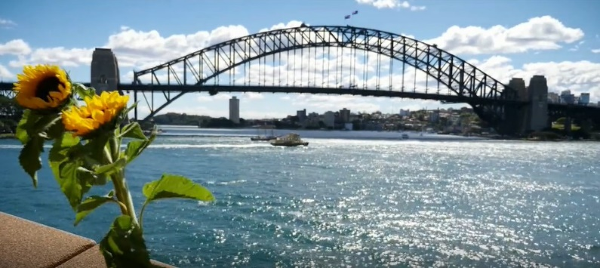
The service will give people the opportunity to come together and share their sorrow in a spirit of comfort and support.

Wesley Mission CEO, Rev Stu Cameron, says the pain of losing someone to suicide is not eased quickly and the journey to healing is complex.

“There is no timetable for grieving. We learn how to deal with our grief and we learn how to live with our loss in different ways. Loss is not forgotten, we grow our lives around it.”

Across Australia, more people are lost to suicide than die on the roads each year. It affects people of all ages, genders and from all backgrounds. Beyond the tragic loss of the person themselves, the impact of each death affects many people who may need grief support. Research indicates that for each person who dies by suicide, up to 135 people are directly affected, including family members, work colleagues, friends and first responders. Bereavement by suicide can impact physical and mental health.

The Wesley LifeForce Memorial Service provides a safe space for people to gather to remember loved ones lost to suicide and honour their memory.

Some people have been attending the service for many years, and for others it may be their first time.

“When we gather together, we stand side by side connected through a shared experience - it is a powerful expression of hope and a reminder for people bereaved by suicide that they are not alone. We also stand together with a shared commitment to reduce the stigma associated with suicide,” says Cameron.
The service incorporates prayer, musical and ceremonial components as well as lived experience speakers sharing their stories around grief and suicide.

People will also be able to leave a message of love and remembrance on a memorial wall and counsellors from StandBy will be present to offer support.

In closing, everyone gathered will be invited to remember their loved one by placing a sunflower in Sydney Harbour. Sunflowers have long been considered a symbol of hope, strength and resilience as the vibrant yellow flower, supported by a strong stem, turns its face towards the sun.

ENDS

For more information, please contact Anne Holt on 0418 628 342 or anne.holt@wesleymission.org.au

About Wesley Mission’s Suicide Prevention work

Wesley LifeForce is a national suicide prevention program run by Wesley Mission that educates, empowers and resources local communities, supporting people most at risk. More than 40,000 people have been trained through the program during the past 15 years.

With a presence in every state, focusing on areas where the problem of suicide hits the hardest, Wesley LifeForce Suicide Prevention Networks are community-led action groups addressing suicide at a local level. So far, there are 130 groups across Australia representing a membership of more than 2,500 people. New networks are being established every year through the support of the Commonwealth Government and Primary Health Networks.
For further information click here.

MEDIA PLEASE NOTE: Most people – including media professionals – have been touched by suicide. For many people, the service will be one of mixed emotions. We ask that you respect the privacy of people who are attending and those participating in the service.

For safe reporting guidelines on suicide go to:
https://everymind.org.au/resources/mindframe-for-media-professionals

People who are experiencing distress can contact Lifeline on 13 11 14.

