TV AND PHOTO OPPORTUNITY
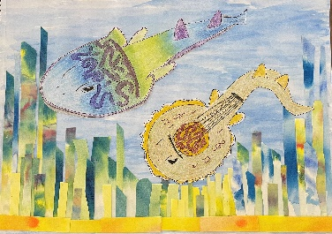
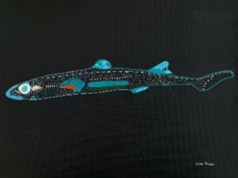
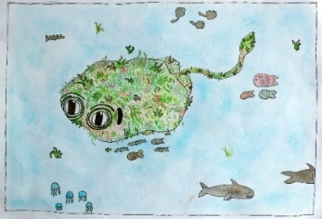
FANTASTICAL SHARKS & RAYS OPENS AT THE AUSTRALIAN MUSEUM

Greenback stingaree Arwen Brown Lined lanternshark Zara Pease Fiddler ray Leah Djikic

WHAT Fantastical Sharks & Rays exhibition launch and preview
WHERE Australian Museum, 1 William Street, Sydney
WHEN Friday 6 September, 10am
WHO Artists - Ken Done, Blak Douglas, Sarah & Sebastian, Jennifer Turpin, Billy Bain, Dion Horstmans, Rosie Deacon and Dylan Mooney.
Australian Museum Director & CEO, Kim McKay AO, AMCS shark expert Dr Leonardo Guida

PHOTOS Children and artists seeing their works for the first time in the Australian Museum gallery

To raise awareness and help protect Australia’s unique lesser-known and endangered species, the Australian Marine Conservation Society (AMCS) and Humane Society International Australia ran a competition last summer asking budding da Vincis to create an artwork depicting one of 10 of them.

- The 10 young winners of the Fantastical Shark & Rays children's art competition will see their portrayals of Australia’s lesser-known and endangered sharks and rays reimagined by renowned artists including Done, Douglas, Sarah & Sebastian, Jennifer Turpin, Billy Bain, Janet Laurence, Dion Horstmans, Rosie Deacon, Dylan Mooney and Jonathan Zawada.
- Exhibition at the Australian Museum from 7 September (National Threatened Species Day) until 8 December, 2024.
- Over 1500 children entered the Fantastical Sharks and Rays art competition

The young winners are:
NSW: Southern/eastern fiddler ray Leah Djikic, 11, Goulburn, NSW. Maugean skate Iluka Michel, 9, Sydney. NSW.
Yellowback stingaree Maya Haysom-McDowell, 10, Sydney, NSW.
QLD: Eastern angelshark Gryff Nolan, 9, Brisbane. QLD. Greeneye spurdog Oliver McIntyre, 7, Sunshine Coast, QLD. Greenback stingaree Arwen Brown, 10, Sunshine Coast, QLD.
NT: Lined lanternshark Zara Pease, 13, Darwin, NT.
VIC: Whitefin swellshark Inara Wilson, 4, Melbourne, VIC.
SA: Longnose skate Eightrielle Escalona, 9, Adelaide, SA.
WA: Melbourne skate Barnaby Snow, 10, Margaret River region, WA.

Artists: Ken Done, Blak Douglas, Janet Laurence, Jennifer Turpin, Sarah and Sebastian, Billy Bain, Jonathan Zawada, Rosie Deacon, Dion Horstmans and Dylan Mooney
For more information or interviews contact: AMCS media advisor Alex Tibbitts: alextibbitts@amcs.org.au / 0416 420 168
AM media advisor Claire Vince: Claire.vince@australian.museum / 0468 726 910
Visit AMCS to learn more about this fantastical competition.

