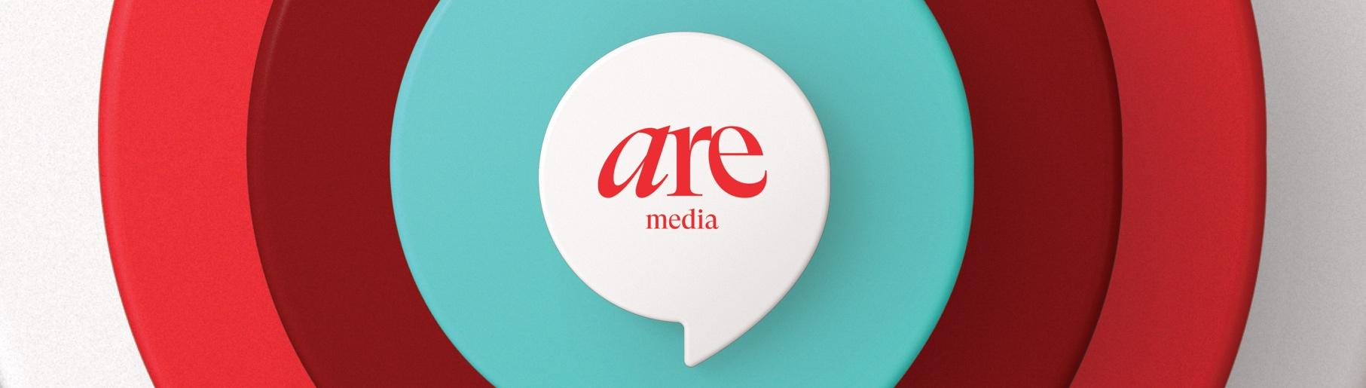Media Release

Saturday 31 August, 2024.

**Jelena Dokic: Women are judged by their weight, but I walk with my head held high no matter what size I am**

Australian tennis champion **Jelena Dokic** has issued a plea for more kindness and says society still sets dangerously high body image standards for women.

In a powerful address to the inaugural ***Australian Women’s Weekly* Health Summit** today**,** the TV presenter and former tennis champion revealed that, after living with an eating disorder for two decades, she’s proud to be embracing who she is.

“I have been all different sizes, from a size 4 to a size 20 so for me it’s been about finding balance and moderation,” she said. “I’ve walked with my head held high no matter what size I've been. We’re imperfectly perfect, but we’re all amazing.”

The wellness advocate, who features on the cover of the September issue of *The Australian Women’s Weekly*, told the audience at Sydney’s **Museum of Contemporary Art** via a video address that women are still body shamed.

“Unfortunately, in today's society we’re defined by our size,” Dokic said. “Our worth is often calculated by a number on a scale, but those are very, very dangerous standards to set, especially for the younger generation.”

During her speech, she called on social media users to combat the bullies and promote kindness.

“We should not be changing our bodies to get respect. Society should be respecting us the way we are because we’re all amazing. If you've got nothing nice to say, please don't say anything at all.”

*The Australian Women’s Weekly* Health Summit was inspired by a major survey last year that found women are more focused on their physical and mental health than ever before. It also highlighted the need for more information and support during menopause.

The sold-out event was emceed by TV presenter **Jessica Rowe** and featured an all-star lineup of speakers and panellists including **Julie Goodwin**, **Jodi Gordon**, **Michelle Bridges** and **Effie Zahos.**

*The Australian Women’s Weekly* Editor **Sophie Tedmanson** said she was honoured to host the magazine’s first-ever summit.

“We couldn’t be prouder to lead the national conversation around women’s health,” she commented. “We’re committed to breaking stigmas around the needs of women and advocating for better healthcare.”

It was a sentiment echoed by Dokic.

“*The Weekly* has always supported women and covered tough stories that need to be told,” she said, adding that anyone struggling with their mental health shouldn’t suffer in silence.

“Please don’t be afraid,” she advised. “Try to ask for help and don’t feel you’ll be judged in any way. It really opens up a lot of possibilities to learn about yourself.”

The Health Summit will also officially launch *The Australian Women’s Weekly* **Walk with the Weekly** to encourage its readers to collectively walk a million minutes throughout September. Official ambassador **Chrissie Swan** is aiming to inspire women to walk for 30 minutes a day to help their physical and mental health while fostering stronger community connections.

“Walking helped me move away from seeing exercise as a punishment,” she said. “I’d love Walk With The Weekly to help other women discover how wonderful it can be.”

To join in, register today at  [www.womensweekly.com.au/walk](http://www.womensweekly.com.au/walk)

Please see link here to Jelena’s opening speech: [(here)](https://drive.google.com/drive/folders/13LtY_6-t1L2BBa4XZ_bUvP5tG076IsjA?usp=sharing)

**To read an exclusive interview with Jelena Dokic, see the September issue of The *Australian Women’s Weekly,* out now.** [Jelena AWW shoot images and bts video](https://drive.google.com/drive/folders/13LtY_6-t1L2BBa4XZ_bUvP5tG076IsjA?usp=sharing)

**For more information:**

Marlene Richardson | GasbagPR

0409 888 218

marlene@gasbagpr.com.au



**About Are Media**

Are Media is Australia’s leading omnichannel content company for women. We connect with 90% of Australian women, igniting intention through our brands including The Australian Women’s Weekly, Better Homes and Gardens, Woman’s Day, marie claire, TV WEEK, New Idea, Now to Love, Australian Gourmet Traveller, BEAUTY/crew and ELLE. With deep insights into what moves, inspires and excites women, we join commercial partners with audiences across print magazines, digital and social channels, TV, video, Australia’s biggest online communities, content commerce and immersive experiences. We create content Australians love across food, fashion, beauty, homes, entertainment, and lifestyle and through our Change AREgenda we drive meaningful and positive change for women. For more information visit [aremedia.com.au](http://aremedia.com.au/)

