AI-Powered Robots Disrupt Asian Grocery Market in Australia

Sydney, Australia – Umall (www.umall.com.au), Australia’s leading online Asian grocery platform, has reached a major milestone in the e-commerce industry. The company has become the first online grocery retailer in Australia to introduce AI-powered robotic sorting technology, a breakthrough that is revolutionizing the way Asian groceries are processed and delivered across the country.
This state-of-the-art automation system, now operational in Umall’s cutting-edge Sydney fulfillment center, marks a significant advancement in the efficiency and accuracy of online grocery operations, particularly in the growing Asian grocery sector.
“At Umall, our focus is on delivering the best possible service to customers who rely on us for their Asian grocery needs,” a spokesperson for the company said. “By implementing AI-powered robotic sorting, we’re not only optimizing our internal processes but also enhancing customer experience with faster, more accurate deliveries.”
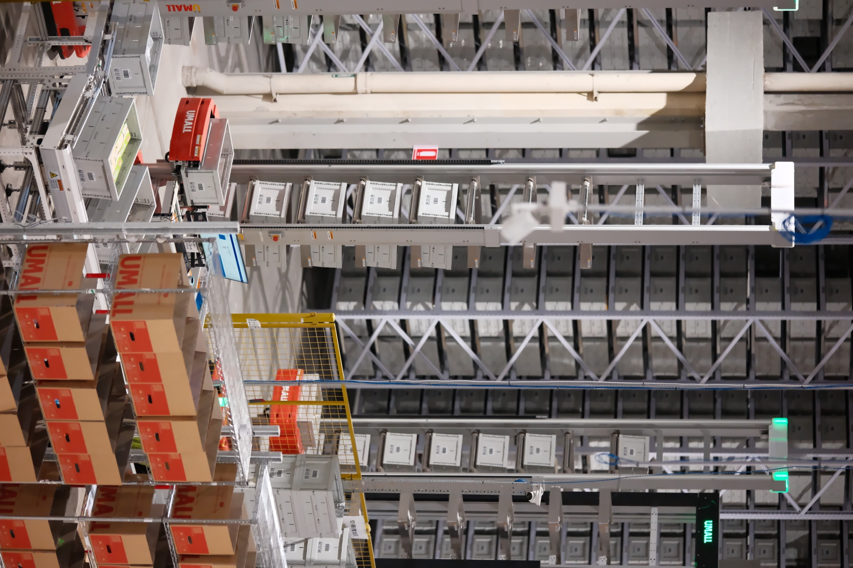

Next-Level Automation
The new AI-driven robotic sorting system has been meticulously engineered to handle the wide range of products unique to Asian grocery markets, from fresh produce to specialty items. Capable of processing thousands of products per hour with pinpoint precision, the system allows Umall to manage its vast inventory of over 20,000 SKUs more effectively. This includes an extensive selection of fresh produce, meats, seafood, and household staples popular in Asian homes.
Key advantages of Umall’s robotic sorting system include:
- Higher Order Accuracy – Significantly reducing errors in selecting specialized Asian grocery products.
- Faster Fulfillment – Enabling same-day delivery in select areas, enhancing customer satisfaction.
- Improved Stock Management – Streamlining inventory control and preventing stockouts of sought-after Asian products.
- Enhanced Food Safety – Minimizing human contact with grocery items, ensuring superior hygiene standards.
This technological leap aligns seamlessly with Umall’s mission to deliver a high-quality Asian grocery shopping experience while maintaining competitive prices and improving logistics efficiency.
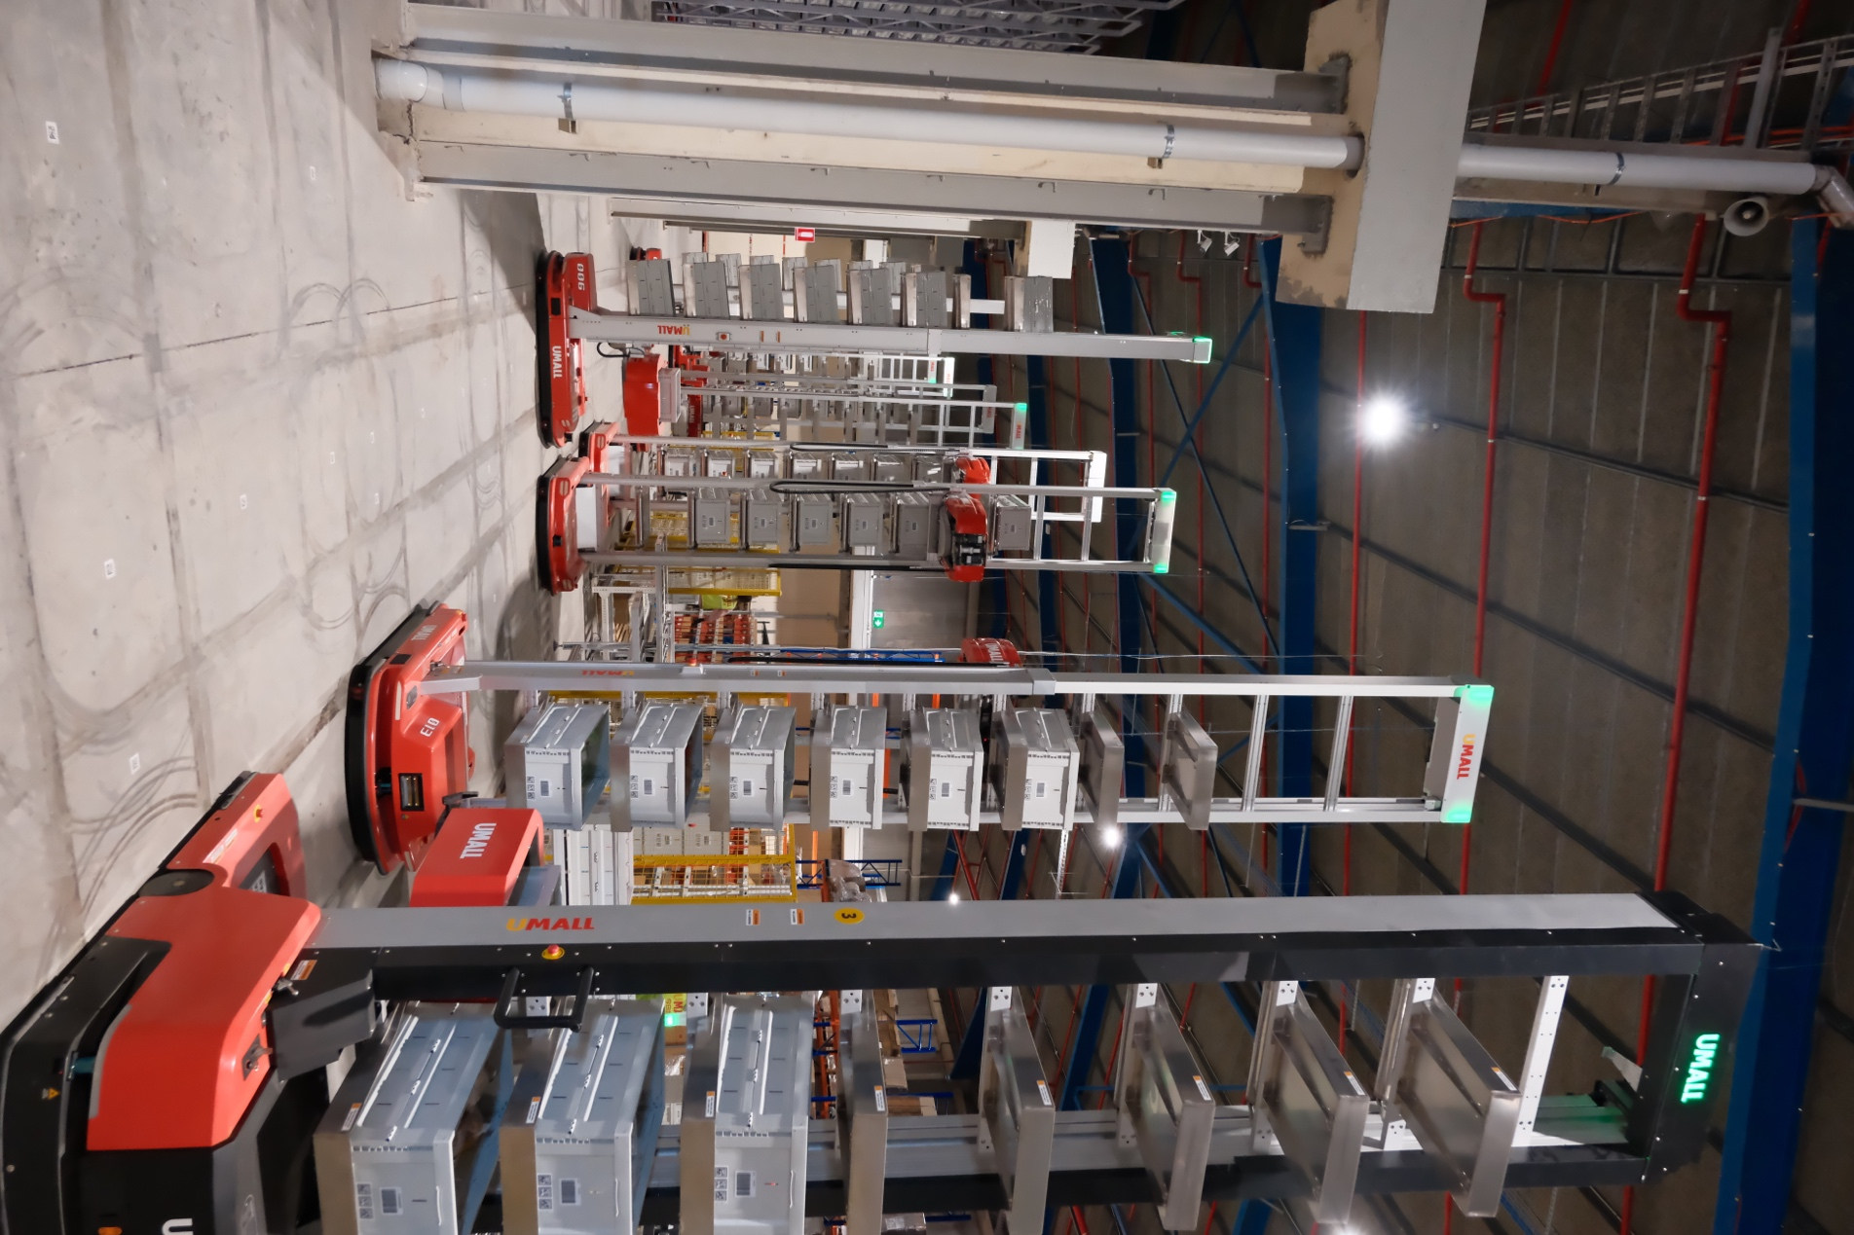

A Game-Changer for Asian Groceries
“The implementation of AI robotics is a game-changer not just for Umall but for the entire online Asian grocery market in Australia,” company representatives emphasized. “This innovation allows us to cater to the rising demand for Asian groceries with greater speed and accuracy, all while expanding our product range and services to better serve our diverse customer base.”
As the first to deploy such advanced AI robotics in the online grocery space, Umall is setting a new standard for the industry. The company has already seen significant improvements in order processing times and customer satisfaction rates, reaffirming its position as a trailblazer in online Asian grocery shopping.
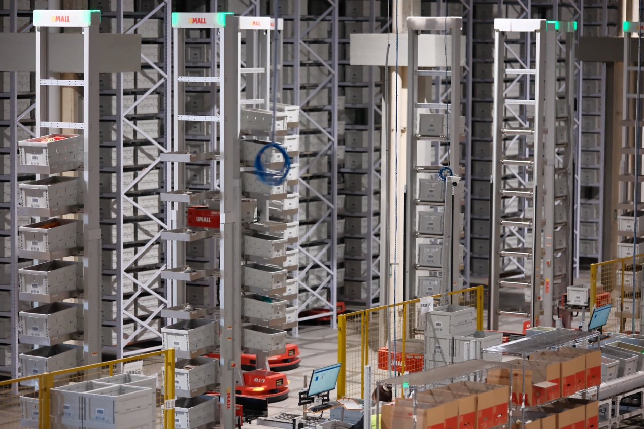

Future Plans
Umall’s investment in AI robotics is only the beginning. The company plans to extend this groundbreaking technology to additional fulfillment centers across Australia in the coming years. This expansion will further solidify Umall’s dominance in the online grocery market and reinforce its commitment to providing the best possible shopping experience for Australians seeking Asian groceries.
For more information on Umall’s innovative approach to online grocery shopping, visit www.umall.com.au.
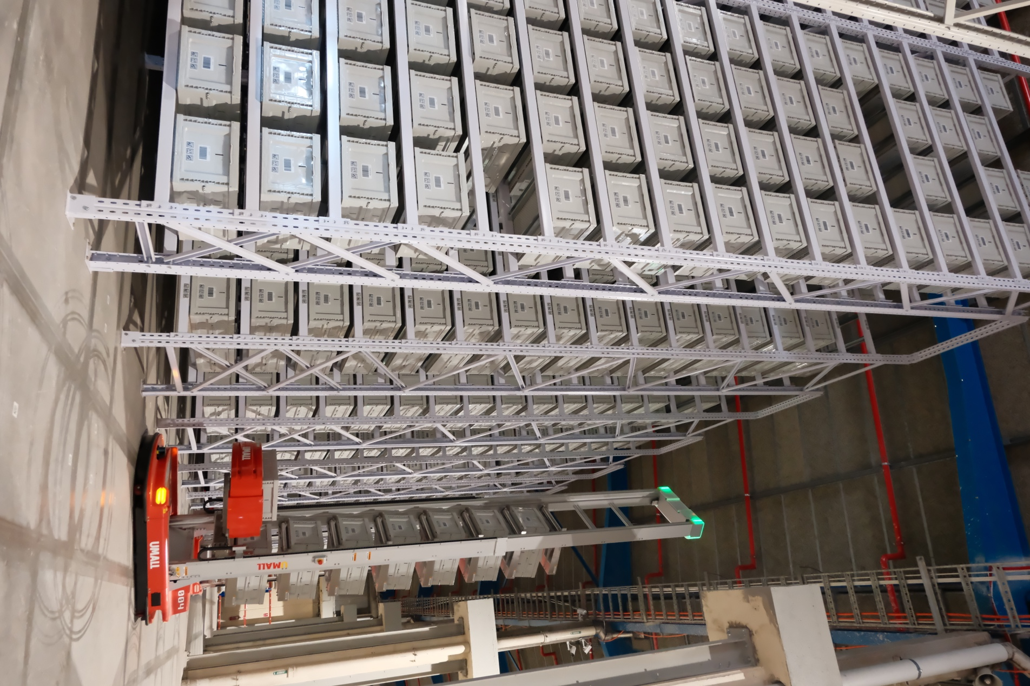
About Umall:
Founded in 2021, Umall is a premier online platform focused on transforming the Asian grocery shopping experience in Australia. Offering over 20,000 SKUs across fresh produce, meats, seafood, snacks, drinks, and household items, Umall delivers high-quality products at competitive prices. By embracing advanced technology and efficient logistics, Umall continues to innovate and redefine how Australians shop for Asian groceries online.

