MEDIA ALERT FOR 6 SEPT 2024 AT 10.45AM

WESLEY (MISSION) LIFEFORCE, LIFELINE AUSTRALIA & SUICIDE PREVENTION AUSTRALIA

Urgently call AGAIN for the Govt to release the National Suicide Prevention Strategy as the nation’s psyche weighs heavy

ABOUT: In the lead up to World Suicide Prevention Day
With suicide deaths (ABS 2021) at more than 2.5 times the national road toll (3,144 deaths), excessive wait times for mental health supports and the cost of living and housing crisis taking a toll, Wesley Mission CEO Stu Cameron, Lifeline Australia CEO Colin Seery and Suicide Prevention Australia A/Director Communications and Advocacy Amelia Hew, are calling for an increase in, and easier access to, suicide prevention services/supports.

Wesley Mission will highlight that half of all people who die by suicide have not connected with the health system and have a level of psychosocial disconnection, making suicide prevention a shared responsibility across the community, including families and friends, professional groups, government and non-government agencies.

Lifeline Australia will give a high-level snapshot of the national psyche highlighting data that shows an increasing number of calls to Lifeline each day are related to financial management, employment, or housing insecurity.
Suicide Prevention Australia will reiterate the government has made a commitment to deliver this foundational work (the National Suicide Prevention Strategy) and demand that it be released in time for World Suicide Prevention Day next week.
The National Strategy was due to be released for public consultation earlier this year and has been in development since late 2022. It will provide a 10-year roadmap that outlines the government’s plan for preventing suicide in Australia.
Also available for interview:
- Andrew Moore – General Manager Wesley Mission LifeForce Suicide Prevention
- Linda - Lived experience and Trainer/facilitator in Suicide awareness and prevention
- Alex Greenwich MP Member for Sydney

Immediately followed by Sydney Harbour Sunflower Ceremony
Immediately following the media call, Stu Cameron, Colin Seery, Amelia Hew, Andrew Moore, Linda, Alex Greenwich and others will each cast a sunflower into Sydney Harbour to honour those lives lost to suicide. Sunflowers have long been considered a symbol of hope, strength and resilience as the vibrant yellow flower, supported by a strong stem, turns its face towards the sun.

WHEN: From 10.45am – with the Sydney Harbour Sunflower Ceremony immediately after

WHERE: Sydney Opera House – Northern Boardwalk outside Yallamundi Rooms, walk along outside path to the rear of the small sails (map below).
Media contact: Anne Holt on 0418 628 342 or anne.holt@wesleymission.org.au

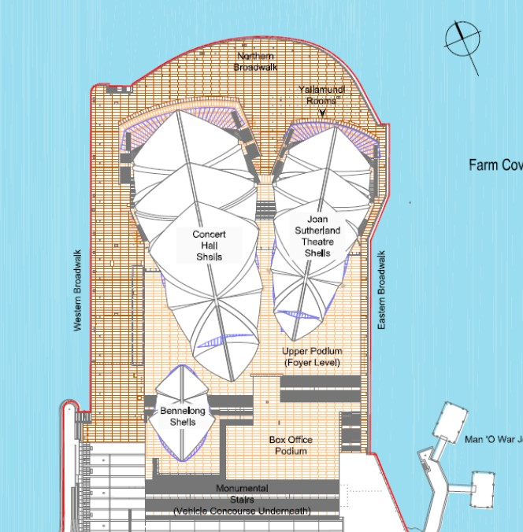
(Sunflower ceremony location indicated by blue X)

About Wesley Mission’s Suicide Prevention work
Wesley LifeForce is a national suicide prevention program run by Wesley Mission that educates, empowers and resources local communities, supporting people most at risk. More than 40,000 people have been trained through the program during the past 15 years.

With a presence in every state and territory, focusing on areas where the problem of suicide hits the hardest, Wesley LifeForce Suicide Prevention Networks are community-led action groups addressing suicide at a local level. So far, there are 130 groups across Australia representing a membership of more than 2,500 people. New networks are being established every year through the support of the Commonwealth Government and Primary Health Networks. For further information click here.

MEDIA PLEASE NOTE: Most people – including media professionals – have been touched by suicide. For many people, the service will be one of mixed emotions. We ask that you respect the privacy of people who are attending and those participating in the service.

For safe reporting guidelines on suicide go to:
https://everymind.org.au/resources/mindframe-for-media-professionals
People who are experiencing distress can contact Lifeline on 13 11 14.

