**FOR IMMEDIATE RELEASE: OCTOBER 2, 2024**

Swarovski’s ‘Masters of Light’ Exhibition Lands In Seoul

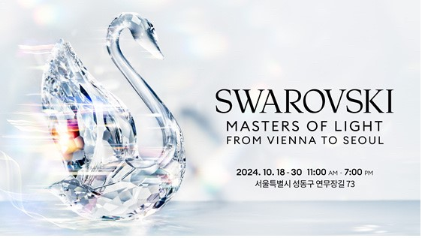

Swarovski’s landmark travelling exhibition arrives in Seoul this fall, celebrating nearly 130 years of the Austrian House’s storied heritage as Masters of Light across the worlds of fashion, jewellery, and pop culture.

Entitled Swarovski - Masters of Light from Vienna to Seoul, the exhibition, which was envisioned by Swarovski Global Creative Director Giovanna Engelbert, premiered in Shanghai last fall, and saw its European launch in Milan this summer.

It opens its doors on October 18 at XYZ Seoul in the vibrant Seongsu district.

The exhibition takes visitors on an immersive journey from the birth of Swarovski in 19th century Vienna to the K-pop scene of 21st-century Seoul through panoramic scenography divided into seven Chambers of Wonder.

Masters of Light showcases a unique array of shimmering stage costumes and red carpet looks worn by stars such as Harry Styles, Rihanna in its Pop Icon chamber, along with costumes from the global K-pop sensations LE SSERAFIM.

In a special display, visitors will see custom outfits from LE SSERAFIM's CRAZY music video, designed in collaboration with Swarovski and embellished to sparkle with every move of the group’s dynamic choreography. Also featured are the crystal microphones used during LE SSERAFIM's recent performance at the 2024 MTV Video Music Awards, adorned with a total of 24,000 Swarovski crystals. The five microphones were individually designed by the group’s members, who each selected their own design and colour combinations.

Masters of Light also brings together an exceptional selection of 10 crystal-embellished masterpieces from fashion houses including Louis Vuitton, Alexander McQueen, and Armani as well as jewellery pieces, figurines, and crystals - including the largest crystal chaton ever created.

Other highlights include showpieces from the ‘Galaxy’, fine jewelry collection made with laboratory grown Swarovski Created Diamonds, and a Pop-Up store where visitors can browse an exclusive Swarovski product assortment.

Mapping a journey through time and space across the brand’s history since 1895, this landmark show is the first exploration of the heritage and revolutionary spirit of one of the oldest European luxury houses.

*Swarovski - Masters of Light from Vienna to Seoul will open to the public from October 18 to October 30, 2024, free of charge. To register for tickets, go to Swarovski Kakao channel.* [*https://booking.kakao.com/short/X1gcVlFwj3*](https://booking.kakao.com/short/X1gcVlFwj3)

For more information, please contact:

Swarovski Global PR: [global.pr@swarovski.com](mailto:global.pr@swarovski.com)

ABOUT SWAROVSKI

Masters of Light Since 1895

Swarovski creates beautiful products of impeccable quality and craftsmanship that bring joy and celebrate individuality.

Founded in 1895 in Austria, the company designs, manufactures, and sells the world's finest crystals, Swarovski Created Diamonds and zirconia, jewellery, and accessories, as well as home décor and crystals for Automotive.

Swarovski Crystal Business is represented in over 140 countries worldwide with 2,300 Swarovski boutiques complemented by selected multibrand partners and employs 16,600 people. Together with its sister companies Swarovski Optik (optical devices) and Tyrolit (abrasives), Swarovski Crystal Business forms the Swarovski Group. A responsible relationship with people and the planet is part of Swarovski’s heritage. Today this legacy is rooted in sustainability measures across the value chain, with an emphasis on circular innovation, championing diversity, inclusion, and self-expression, and in the philanthropic work of the Swarovski Foundation, which supports charitable organisations bringing positive environmental and social impact.