**FOR IMMEDIATE RELEASE SEPTEMBER 2024**

**Homemade Ice Cream: Easier Than You Think!**

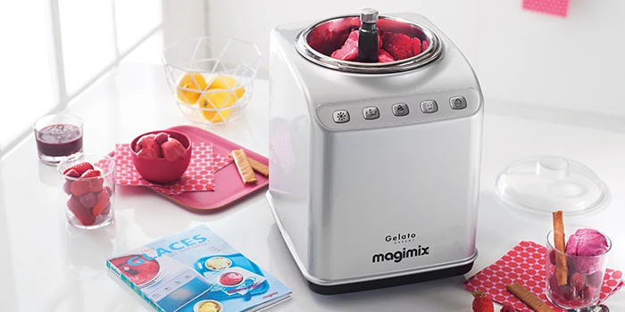

As the weather warms up and the days grow longer, nothing beats the refreshing joy of homemade ice cream. But if you think creating your own ice cream at home is too complicated, think again! Making delicious frozen treats is easier than ever, and there are plenty of quick recipes that don’t even require cooking a custard.

**Why Make Ice Cream at Home?**

* **Customisable Creations** – Whether you’re catering to specific dietary needs, like dairy-free or sugar-free, or experimenting with unique flavours, homemade ice cream allows you full control over ingredients.
* **Healthier Options** – When you make ice cream yourself, you can choose high-quality ingredients, avoid artificial additives, and adjust sweetness to your liking, creating a more wholesome indulgence.
* **Save Money** – Premium ice cream brands can be pricey, but making your own is cost-effective, especially if you're making large batches.
* **Fun for All Ages** – Creating ice cream at home is an activity the whole family can enjoy. From picking flavours to adding mix-ins, it's a delightful way to bring everyone together in the kitchen.

**Easy Ice Cream Recipes (No Custard Needed!)**

If you’re looking to make ice cream without the hassle of cooking a custard, try these simple options:

**Quick & Easy Vanilla Ice Cream:** Just combine cream, milk, sugar, salt and vanilla extract and churn! You can then choose to consume on its own, or mix in a variety of fun ingredients, like your favourite biscuits or even puréed fruit. The possibilities are endless with this homemade ice cream base.

For 8 people:

1 L cream (4 cups)

500 ml full cream milk (2 cups)

320 g caster sugar ( 1 and 1/2 cup)

Pinch salt

1 Tbsp vanilla extract or other mix-ins

Turn the Gelato Expert On. In a large bowl, whisk together all the ingredients (except mix-ins) until the sugar is fully dissolved.

Pour the mixture into the Gelato Expert machine. Select the GELATO function. When the ice cream looks like it is nearly finished, add your mix-ins of choice. Let the machine churn to incorporate the toppings.

Serve immediately.

**Banana “Nice Cream”:** All you need is a blender to combine all the ingredients of this healthy ice cream together.

For 6 people:

475ml cream

3 ripe bananas

395g condensed milk

100g full cream milk

Blend the bananas and milk together until smooth. Place the rest of the ingredients in the blender and blend until all ingredients are incorporated.

Pour the mixture into the Gelato Expert machine. Select the ICE CREAM function.

Serve immediately.

**Champagne Berry Sorbet:** A refreshing and elegant sorbet blending the crisp effervescence of champagne with the vibrant sweetness of fresh berries, perfect for summer entertaining.

For 8 people:

200g sugar

237ml water

492g raspberries (fresh or frozen)

350ml champagne or sparkling wine

Puree the raspberries. You can do so using a juicer, or blend the raspberries and pour through a strainer to remove the seeds.

In a separate bowl, combine sugar, water and champagne. Stir carefully until the sugar has dissolved.

Add the champagne mixture and raspberry puree into the Gelato Expert. Select the GRANITA function.

Serve immediately with fresh raspberries and mint leaves.

**Make it Even Easier with Magimix Gelato Expert**

With the Magimix Gelato Expert, whipping up ice cream at home has never been more effortless. This commercial-grade ice cream maker is equipped with a built-in freezer, so there’s no need to pre-freeze the bowl. Simply pour in your ingredients, and the Gelato Expert will handle the rest.

With its pre-set programs for ice cream, gelato, and granita/sorbet, you can create a variety of frozen treats at the touch of a button.

Ready to make ice cream on a whim? The Gelato Expert allows you to go from ingredients to delicious homemade ice cream in as little as 30 minutes. Whether you’re a seasoned dessert enthusiast or just starting, the Magimix Gelato Expert simplifies the process, bringing a taste of Italy right into your kitchen.

Discover the joy of homemade ice cream and unleash your inner ice cream artist with the Magimix Gelato Expert.

*Magimix is a beloved French brand with a rich history in culinary innovation. As the original inventor of the food processor, Magimix has been a trusted name in kitchens around the world for over 50 years. Magimix Appliances are available at David Jones, Myer, Kitchen Warehouse, TVSN, selected high end kitchen shops and online through* [*www.magimix.com.au*](http://www.magimix.com.au)*.*

###

Images: <https://www.dropbox.com/scl/fo/js8eb81iu4677wqf3f776/APo2c27rjCJl9KbbVjptlmA?rlkey=97dvgub3apod0lg7c8bscp6y2&st=vfvy47cv&dl=0>

For more information, photos or to arrange an interview, please contact:

**Meg Reyes**

**1300 624 469 | megr@magimix.com.au**

**Website:** magimix.com.au

**Facebook:** Magimix Australia

**Instagram**: @magimix_australia

**YouTube**: Magimix Aus

**About Magimix**

Born out of Burgundy, an internationally renowned region for gastronomy, Magimix has been designing and making high-quality premium kitchen appliances for 50 years. With our roots in professional products designed for commercial use, creating great quality food is at the heart of everything we do - providing a helping hand to ensure all kitchen needs are met - be it slicing, grating, chopping, whisking, juicing, blending or kneading. As the inventors of the World's first Food Processor, we continue to focus on combining the best cooking traditions with today’s technology across our entire product range. To many, the enduring appeal of Magimix is that its products are built better to last longer – a statement strengthened by the longest guarantees and best after-sale service. Magimix has been an eco-friendly company since the very beginning, respecting its basic aim of designing and making simple, efficient, lasting products. The world’s top restaurants use the professional versions of our products and true to our origins, are always at the forefront of innovation. Designed and made in France, Magimix is the perfect aid for all your food preparations.