Invasive Meningococcal Disease awareness campaign
Lived experience profile: Felicity and Tom Harley
Prepared by Palin Communications
For GSK Australia
This version: 10 September 2024

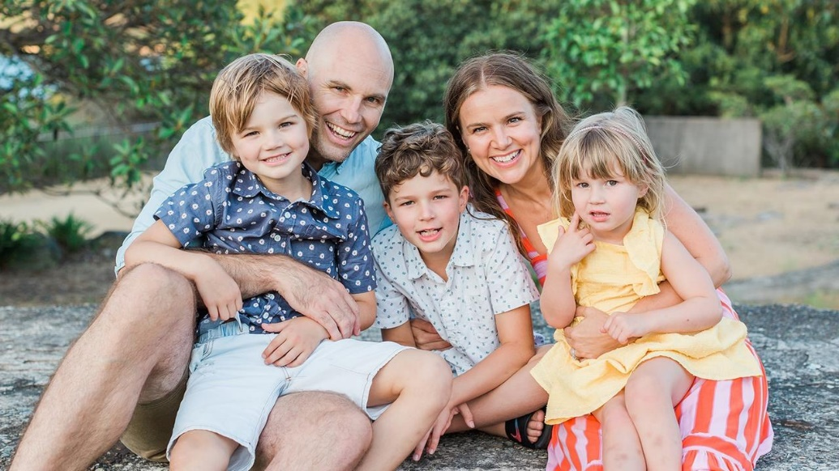

Felicity Harley is one of the most respected women in media – she currently hosts Body+Soul’s award-winning podcasts, Healthy-ish and Extra Healthy-ish, and is author of Balance & Other B.S.
Tom Harley a former professional AFL player, sport legend and is currently the CEO of the Sydney Swans.
Felicity and Tom’s son Hugo was just five-weeks-old when he contracted invasive meningococcal disease, a rare but potentially fatal and fast acting bacterial infection. The couple now supports awareness raising activities to educate other parents about the nature of the meningococcal disease, signs and symptoms to look out for.

