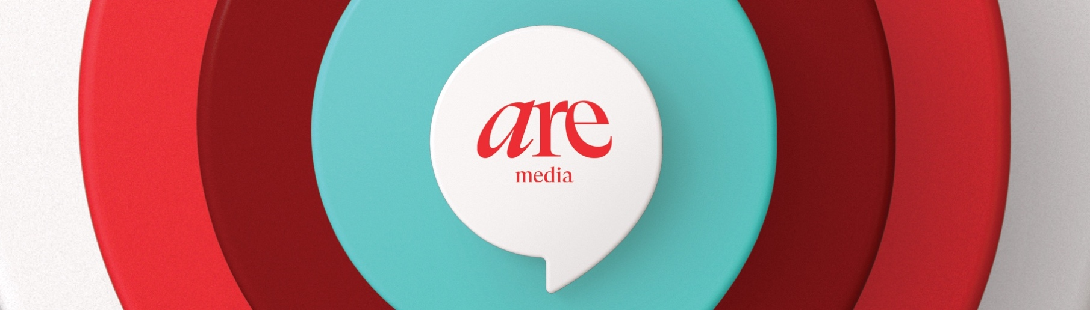Media Release

Saturday 31 August 2024.

**Myf Warhurst: women must talk more about menopause to empower the next generation**

***Spicks & Specks* star opens up about her acute lack of knowledge at**

***Australian Women’s Weekly Health Summit in Sydney***

Radio and TV star Myf Warhurst today called for more open discussion on menopause and said that her generation needs to empower younger women about what to expect.

“My mum certainly didn’t talk about it and even when I chatted to my friends, none of us had the right information or knowledge about what was going to happen,” she told Saturday’s ***Australian Women’s Weekly Health Summit.***

Myf revealed that she’d been reluctant when she was asked to host an ABC documentary on the subject.

“I thought ‘No, not me!’ I’d internalised embarrassment and shame about ageing,” she said. “I could have talked about Beatles albums in great depth, but I didn’t know very basic facts about menopause.

“Really, we should be comfortable about it so we can empower the next generation about how to cope. Because it isn’t a breeze! My body had gone through so many things, but I'd never experienced anything like menopause before.”

Myf was part of a star-studded lineup that included emcee **Jessica Rowe**, TV cook **Julie Goodwin,** actress **Jodi Gordon**, fitness queen **Michelle Bridges,** and Channel Nine money expert **Effie Zahos.**

Author **Alison Daddo**, who wrote a book called *Queen Menopause*, told the sold-out event at Sydney’s Museum of Contemporary Art that she too was unprepared for menopause and it had driven her to question whether she wanted to go on living.

“I was hit with symptoms beyond my understanding,” she said. “Mood swings, sleep deprivation, physical pain, depression and really high levels of stress. I was a working mum but had no clue about self-care. I was horrified to realise that so few women knew about it.”

The summit was inspired by a major survey that highlighted the need for much more information and support during menopause.

Tennis champion **Jelena Dokic**, cover star of The *Australian Women’s Weekly* September issue, delivered a powerful welcome message revealing that she’d struggled with an eating disorder for two decades and has only recently learned to embrace who she is.

“I’ve been all different sizes from a 4 to a 20 and walked with my head held high no matter what size I've been. We’re imperfectly perfect, but we’re all amazing.”

Throughout Saturday morning, a series of expert panels and guest speakers covered a wide range of topics from wellbeing and fitness to financial health and nutrition.

A Mental Health & Wellness discussion featured Indigenous counsellor **Dr Liz Dale, Jodi Gordon,** and **Julie Goodwin** talking about ways they have navigated challenges in their lives and the need to destigmatise anxiety and depression.

Julie opened up about her struggles with mental health and warned that the journey back to wellness isn’t an easy ride.

“Recovery takes a long time, but you have to keep going. It’s a bumpy road and you’ll check into the Sad Hotel a few times, but eventually, you can come home to joy.”

Another major cause of middle-life depression can be money worries. **Effie Zahos** told the audience that she only got into finance because she was terrified about where she might end up.

“I had a fear that when I retired, I’d be in polyester outfits and drinking cask wine,” she admitted. “I wish my parents spoke about money more” she said. “What women don’t do well is build wealth through investing because they don’t have the information. Even if you’re in your 60’s and 70s, it’s never too late.”

*The Australian Women’s Weekly* is also launching **Walk with the Weekly** to encourage its readers to collectively walk a million minutes throughout September. Official ambassador **Chrissie Swan** is aiming to inspire women to walk for 30 minutes a day to help their physical and mental health while fostering stronger community connections.

“Walking helped me move away from seeing exercise as a punishment,” she said. “I’d love Walk With The Weekly to help other women discover how wonderful it can be.”

To join in, register today at [www.womensweekly.com.au](http://www.womensweekly.com.au).

*Australian Women’s Weekly* Editor **Sophie Tedmanson**, said: “We couldn’t be prouder to lead the national conversation around women’s health with our inaugural Health Summit and Walk With The Weekly. We’re committed to breaking stigmas around the needs of women and healthcare and encouraging women to advocate for themselves.”

See link here for event images [(here)](https://drive.google.com/drive/folders/1Ua28VFzz8dhELRq4_TT_KS6pInBr4kFA?usp=sharing)

**For more information:**

Marlene Richardson | GasbagPR

0409 888 218

marlene@gasbagpr.com.au



**About Are Media**

Are Media is Australia’s leading omnichannel content company for women. We connect with 90% of Australian women, igniting intention through our brands including The Australian Women’s Weekly, Better Homes and Gardens, Woman’s Day, marie claire, TV WEEK, New Idea, Now to Love, Australian Gourmet Traveller, BEAUTY/crew and ELLE. With deep insights into what moves, inspires and excites women, we join commercial partners with audiences across print magazines, digital and social channels, TV, video, Australia’s biggest online communities, content commerce and immersive experiences. We create content Australians love across food, fashion, beauty, homes, entertainment, and lifestyle and through our Change AREgenda we drive meaningful and positive change for women. For more information visit [aremedia.com.au](http://aremedia.com.au/)

