Invasive Meningococcal Disease awareness campaign
External experts profile: Dr Sam Hay
Prepared by Palin Communications
For GSK Australia
This version: 10 September 2024
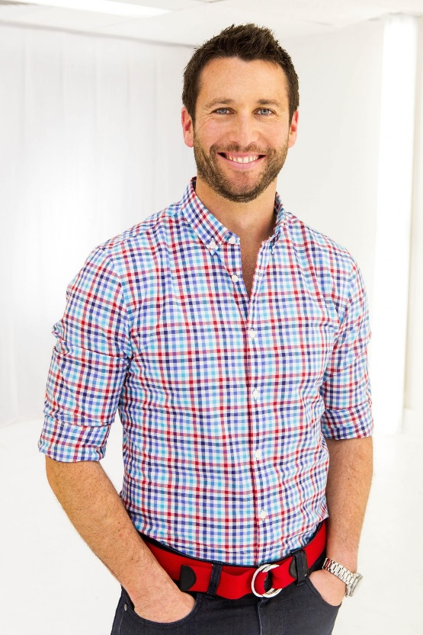

Dr Sam has been a practicing general practitioner since 2005. He is well known across all forms of media, reaching hundreds of thousands of Aussies every week as a relatable health expert. He is able to draw on his role as a father to three kids, a professional background as a military officer, and his current life as a general practitioner.
His major credits include Dr Kiis with the Kyle and Jackie O Show, broadcasting a regular segment on the Kiis network, health expert for Kidspot and host of Embarrassing Bodies Down Under and Amazing Medical Stories.
Dr Sam is involved in a number of public campaigns and he works closely with various health charities to help look for new ways to educate people in health matters.

